WCLN LTI Integration

2019/02/14

# Introduction

Currently we are able to manually add WCLN LTI books and pages to Canvas easily. However, we do not want to manually go through every LTI course we are distributing from Moodle and set it up in Canvas. WCLN distributes courses by backing up the course to a Moodle backup file and then consumer sites restore the course to their own instance of Moodle. This works fine using our current LTI implementation (custom parameters). However, I am not sure how this will work in Canvas.

# Adding LTI Books in Moodle

Here is the flow of how we are adding an LTI book in Moodle.

1. WCLN LTI Book and WCLN LTI Page are set up as preconfigured LTI tools. This configuration includes setting the launch URL, consumer key etc…
2. Browse to a course and click ‘Add an Activity or Resource’.
3. Select WCLN LTI Book or WCLN LTI Page.
4. Enter a title for the new resource.
5. Enter an ‘id’ as a custom parameter. This is used to identify the Book or Page we want.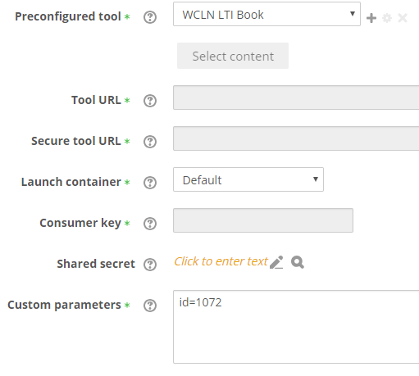
6. The resource is loaded via LTI. 

# Distributing LTI Courses

With the above configuration for specifying the ID, each book or page resource contains the custom parameter. This means that when we backup the course containing LTI material, the book ID or page ID is included in the backup. When we restore this backup on a consumer site, the WCLN preconfigured tools are automatically added. The only configuration required by the consumer site is setting their consumer ID and shared secret on the following page.

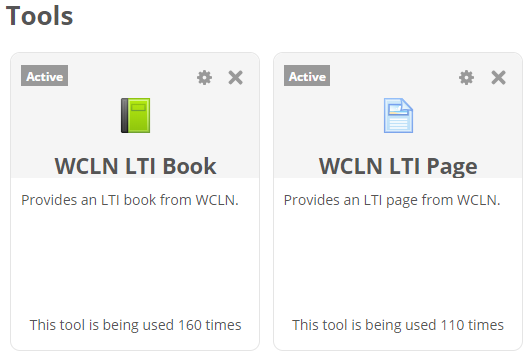

# Issues Distributing to Canvas

Canvas is different in that when setting up an LTI activity, one is not able to specify a custom parameter for that specific activity. Every activity uses the same custom parameters from the external tool configuration.

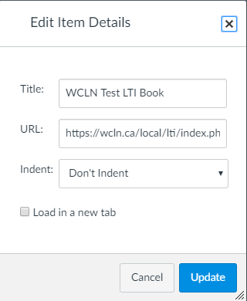

However, in Canvas one is able to edit the launch URL for each tool instance. This means that the book ID or page ID can be appended to the end of the launch URL. For example: https://wcln.ca/lti/index.php?**id=1072**.

This works fine when manually setting up books and pages for testing. I have no concerns with how our LTI displays in Canvas. However, I am worried about how we will distribute these LTI courses to Canvas. Since there is no custom parameter field for each LTI resource, what will happen to the IDs referencing the book or page resources?

I am curious if Canvas has dealt with this problem before, and if they have a solution for it. One possible solution is using a script to parse the backup file, and for each LTI resource, appending the custom parameter ID to the launch URL when restoring a course to Canvas.

The other solution I can see is Canvas providing some other custom field or setting for our tool which can be populated by the custom parameters when a course is restored.

# Resource Linking

Jeremy May suggested the following:

*“Alternatively they can use the item placement parameter in the LTI standard to identify each link individually. Like our LTI for Practice on first launch by a user with a teacher role they can then select the resource and the tool maps the placement id to the resource in the back end.”*

I have implemented this in our LTI provider and it works as follows:

1. Browse to a course and click ‘Add an Activity or Resource”.
2. Select WCLN Book or WCLN Page.
3. Enter a title for the new resource. Do **NOT** enter any custom parameters.
4. Click ‘Save and Display’. The following appears if the logged in user is a Teacher or greater. 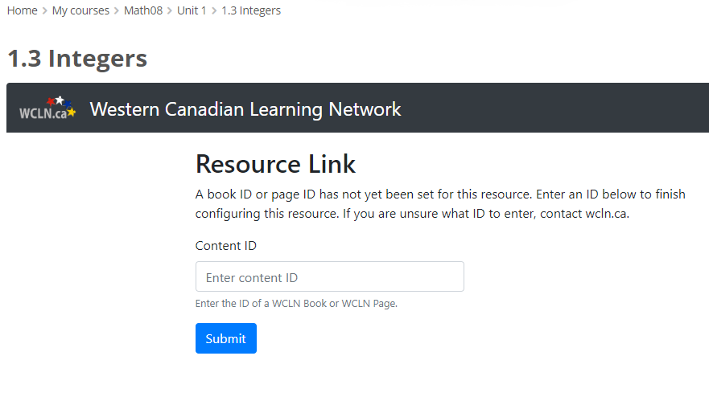
5. Enter a book ID or page ID and click ‘Submit’.
6. The unique ID of this resource, the consumer ID, and the book/page ID are stored in a resource linking database table.
7. The page refreshes and loads the requested resource.

This solution works fantastically for adding new LTI resources on our site, and I like that it can keep track of the usage of each resource. However, if we backup the course, there is no custom parameter to be included with each resource (since these parameters are now stored in our database). This means that when we go to distribute our courses, every LTI resource would have to be re-linked.

I am curious if Canvas has dealt with distributing this type of LTI resource linking. Would something like this be easier to import into Canvas?

So far, it appears that setting the custom parameter is the easier solution, as it does not affect our ability to distribute to our Moodle consumers.